Isabelle Anno
2/24/2022
Assignment 7

- Describe the difference between a clustered index and a non-clustered index in regard to their B-Trees.

The leaf level of a clustered index is the actual row in the table, whereas with an unclustered index, the leaf levels contain only key columns and no actual data.

- What are the three cases in which a clustered index is the most efficient index for retrieving data?

- Queries that return most of the columns in the table
- Queries that return ONE row based on the clustered index key
- Queries that return range-based data (like a scale of 1-10 for example)

- What are two cases in which a non-clustered index is the most efficient index for retrieving data?

- Queries that return few rows
- Queries that can be covered by the index

4.) Create a NONCLUSTERED index

- Create a T-SQL command to create a NONCLUSTERED index on the LastName column of the Owner table in your AnimalHealth database (Recall this database and table were created in Week 3).

Use AnimalHealth;

CREATE NONCLUSTERED INDEX index_LastName ON Owner (LastName)

- Run the above command
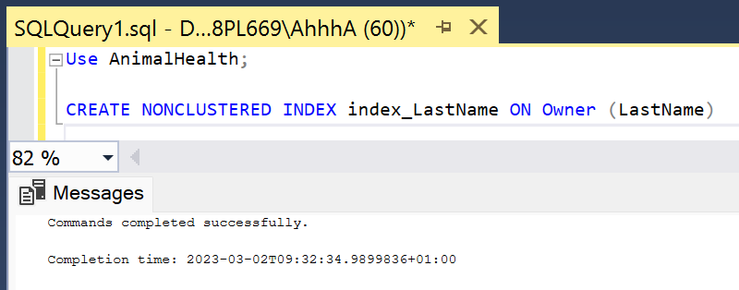

- Use the Object Explorer window to examine the created indexes for this table (Expand table->Expand Indexes)
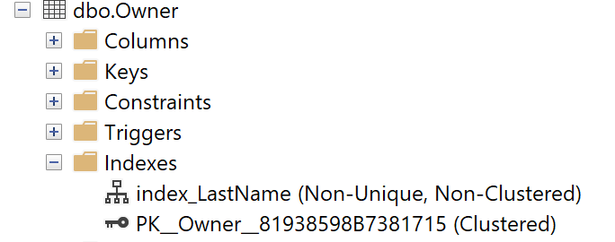

5.) Which index type was first introduced in the 2012 version of Microsoft SQL Server?

Columnstore Indexes.

6.) What is the main advantage to making an index a filtered index?

With a filtered index, you can make a index that is highly selective to small portions of data, which narrows things down quite a bit.

7.) Examine the following Query:

SELECT Description, AvailabilityDt, Price FROM

Production.Products

WHERE Description LIKE ‘Air%’

ORDER BY Description, AvailabilityDt

Imagine that we have millions of rows of data in this table and that queries such as the above are executed repeatedly for many reports. If you notice we are going after all of the products where the Description matches a certain value (using a wildcard) and returns the Description, AvailabilityDt, and the Price. The query orders the results by Description first, and then by AvailabilityDt. We want to design a Nonclustered index to speed up our search results for the above query.

- Determine which columns should be part of the index and in which order. You do not need to create the index but provide your feedback as to which columns you would include in the index and in which order.

When creating a nonclustered index, some of the best practices are to use the same column order as in your WHERE clause, which is why I would include Description, then AvailabilityDt because it’s in the ORDER BY clause. Description is also going first because it is more selective than AvailabilityDt.

8.) Assume that we want to use the following query.

SELECT LastName, FirstName, SSN

FROM Students

WHERE LastName = 'Jones';

Would the following index be a covered index for the above query? Why or why not?

CREATE NONCLUSTERED INDEX idx_LastName ON Students(LastName)

From my understanding, an index is covered when all requested data is in the index and there is no need to further look into the clustered index. In this query, we are asking for the first and last name and social security number, however in the nonclustered key provided, the only thing we are looking at is the LastName column. SQL Server will use that nonclustered index for the last name but will still need more information- so not all the data is “covered” by the index. So no, I don’t think this is a covered index.

9.) What is the maximum number of CLUSTERED indexes that can exist for a table?

One

10.) Assume that you have a table named Student and you are considering adding nonclustered index(es) to this table. Without knowing any information at this point about the SELECT queries that will be used against this table, consider the following columns that both belong to table Student: FirstName and Graduated. FirstName is a VARCHAR column that stores the first name of the student and Graduated is a BIT type that stores either a 0 (not graduated) or a 1 (graduated). Which column – FirstName or Graduated – is a more selective column and why would it matter if a column is selective or not when considering indexes?

Selectivity refers to data types that are more specific. Since Graduated is a BIT data type and can only have 0’s and 1’s, it is not as selective as FirstName, which can have a million different values. I like to think of it like this: If you were to try to scroll through the table manually to find a specific student, knowing only their first name and whether or not they graduated, would you look at the “first name” column or the “graduated column”? You’d want to look at the first name column because it’s more unique & easier to find.

